REQUESTS FOR PROJECTS

Eligible Applicants: Non-profit organizations or individuals serving students in grades K-5 located in South Lake Tahoe, California. This could include PTAs, teachers, after-school programs, a group of classrooms, etc.

Questions: Any questions on this RFP email: info@bookmode.org
Answers: Posted to www.bookmode.org/rfp
Due Date: December 16, 2022 by 5pm PST

Background: BookMode was created by two South Tahoe High School alumni with a mission to help kids become young, enthusiastic readers that grow into adults with a lifelong passion for learning. We believe that if a child is excited about reading at a young age, then they will discover the inexhaustible magic, hope, and wonder that can be found in a simple moment of time immersed in an amazing story. Books act as mirrors into our own souls and windows into worlds unknown, and it is our belief that if we give kids access to books, they will discover treasure hidden in each one. BookMode seeks to get kids excited about reading and give them access to thousands of books and audiobooks with technology that generations past could only imagine.

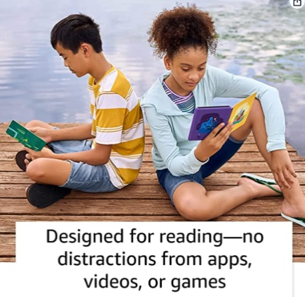
Grant Award: BookMode will give each child in your grant application their very own Kindle Paperwhite and Bluetooth headset to keep! No strings attached. Each Kindle comes with 1 year subscription of Amazon Kids+ with access to thousands of books in English and Spanish. We are especially excited about the Audible feature on Paperwhites, which lets kids switch seamlessly between reading and listening. This is a great feature for language learners. Please see all device features here.

We will provide:
- Kindle Paperwhites for each child
- A Bluetooth Headset for each child
- A Kick-Off Event
- BookMode stickers and SWAG as reading incentives
- A Reading Dashboard – showing you how many books have been opened and read on your project devices

Reading for Enjoyment: Our only request is that you use Kindles to help inspire the love of reading in the children you serve. We do not envision these being used in curriculum or for book reports. Our hope is that these are given with the simple intent to stimulate recreational reading, enjoyment, and enrichment.

Kick-off event: If desired, BookMode can host a kick-off event at your organization on the Power to Read. Our Reading Superhero’s (retired teachers) LOVE to read, and can’t wait to share that passion with the children you serve. At this event, we will also teach them how to use their Kindle Paperwhite. We can provide ongoing training and technical support, as needed.

Program Objectives:
- To inspire kids to read and genuinely enjoy it!
- To help kids establish daily reading habits
- To provide language learners with access books in both English and Spanish
- To encourage listening to books on audible as a way to enjoy learning

We will give you Kindles, bluetooth headsets, a kick-off event, and technical support. What can you bring to the table? How can you use these tools to inspire the love of reading in the children that you serve? We want to hear your ideas and hope to select several projects in a variety of settings. We are open to your creativity!
Grant Application Form
Applicant:
Contact Person:
Email:
Phone:
Physical Address:
Number of Kindles and headsets requested (Up to 100 per applicant):
How will your project ignite the love of reading in the children that you serve?
Please describe the need for these devices in your classroom, school, or organization
Please describe how you will use the Kindles? Will you gift them to kids for use at home or will you incorporate them into your ongoing activities (either is acceptable)
How is your project innovative or creative?
How will you encourage kids to read on their Kindles?
Would you like BookMode to host a kick-off event? Please provide a few dates (subject to change)
Would you like BookMode to sponsor a reading challenge? Please list what you’d like us to provide.
Is there any other way that BookMode can help ignite the love of reading in the kids that you serve?

Email completed grant application to info@bookmode.org by December 16, 2022
About us: BookMode is a project funded by generous grants from the Marcella Foundation, Lift Literature, and the Tahoe Women’s community fund.

